The Weather Application
Release 1.0

The following application was designed to capture temperature and rainfall by city and state. There is only one input screen, one file and one report. Each field on the following input screen can be modified (add, changed or deleted). The add and change functions are different. All previous entries viewed by usi

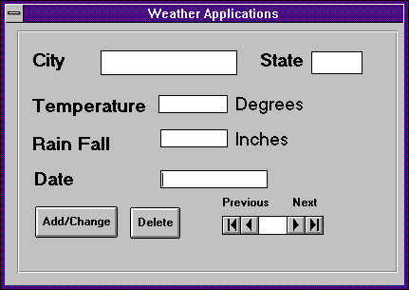

Weather Storage File
City | State | Temperature | Rain Fall | Date

Average Temperature and Rain Fall by City and State
 |  | Temperature | Rain Fall | Date
City 1 | State 1
 | Detail Readings for City 1
 | Averages
City 2 | State 2
 | Detail Readings for City2
 | Averages

Based on the weather application fill in the following table. The exercise is designed to identify the exact number of data elements.

Component (EI,EO, EQ, ILF and EIF) | Number of Data Elements? | What are the data elements?
EI (generar Bitácora) | 20 | Nombre, Fecha, Cap. del camión, Rev. de papeleo, Núm. de ruta, Hora de salida, Hora de regreso, Número del camión, Número de caja, Km Inicial, Km Final, Comentario sobre ruta, No. De remisión, Nombre del cliente, Hora de llegada con el cliente, Hora de salida con el cliente, Comentarios para el cliente, Tiempo de descargar el camión, Botón Registrar, Mensaje de confirmación.
EI (eliminar Bitácora
EI (Modificar Bitácora
EQ (consulta Bitácora)
EQ (consulta Eliminar)
EQ (consulta Modificar)

What is the total unadjusted number of function points?

COMPLEJIDAD FUNCIONAL
 | BAJA |  |  |  | MEDIA |  |  |  | ALTO |  |  |  | TOTAL
External input | 3 | x | 3 | 9 |  | x | 4 |  |  | x | 6 |  | 9
External output | 1 | x | 4 | 4 |  | x | 5 |  |  | x | 7 |  | 4
External Inquery | 1 | x | 3 | 3 |  | x | 4 |  |  | x | 6 |  | 3
Internal Logic File | 1 | x | 7 | 7 |  | x | 10 |  |  | x | 15 |  | 7
External Logical File |  | x | 5 |  |  | x | 7 |  |  | x | 10
Puntos de función no ajustados |  |  |  |  |  |  |  |  |  |  |  |  | 23
Multiplicado por el factor de valor de ajuste
Total puntos de función ajustados

